
OPERATIONAL EXCELLENCE | DIAGNOSTIC REPORT
Gemba Walk & Initial
Diagnostic Assessment
Store Optimization Project
Initial diagnostic study of shop-floor material use and store operations
Organization / Facility | Cosmos Air Distribution Products
Prepared by | Mahir Valani
Date | 15/05/2026
Document version | v0.1 — First draft for review
Status | Draft — observations pending validation

Table of Contents
1. Executive Summary 3
2. Objective and Scope 4
2.1 Objective 4
2.2 Scope 4
2.3 Conceptual view of the study area 4
3. Gemba Walk Methodology 5
4. Gemba Walk Template: Five-Stage Assessment 6
4.1 Preparation 6
4.2 Observation 7
4.3 Improvement Opportunities 8
4.4 Follow-Up Actions 11
4.5 Reflection 12
5. Consolidated Diagnostic Findings 13
6. Recommended Next Steps 14
Appendix A: Photographic Evidence 16

Headings use Word heading styles. To insert an automatic table of contents instead, use References › Table of Contents; page numbers shown here are static — refresh them manually after editing.

1. Executive Summary
A Gemba Walk was carried out as the first diagnostic step of the Store Optimization Project at a manufacturing facility. Its purpose was to understand, at the place where the work happens, how materials are used on the shop floor, how they are stored and handled in the stores, and where operational problems arise in daily work — before any structured improvement is designed.
The walk followed a deliberate sequence. I first visited the shop floor to see which materials are used in actual operations, and then visited the stores to see how those materials are stored and handled. Existing processes and day-to-day problems were observed, a feedback mechanism was used to capture operational issues and inputs, and the problems identified were prioritized by severity.

Major categories of issues observed
- Storage and space utilization: Same materials in different locations, storage without structured racks, materials on the floor, long-held stock and no evident scrap / obsolete disposal mechanism.
- Identification and inventory visibility: No consistent labeling, stock-visibility and stockout challenges, and manual effort in counting.
- Material movement and accessibility: No point-of-use storage, increasing handling and labour movement.
- Store management practices: No structured 5S, FIFO, Kanban replenishment, binning or kitting evident during the walk.

How to read this report
All findings are initial observations made during one walk. They are not independently verified root causes, and “not evident” means not seen during the walk — not that a practice is absent from the facility. No quantified time study, root-cause analysis or employee survey is claimed, and no improvement has been achieved or measured yet.

Why a structured diagnostic is required. Solutions such as racks, labels, bins, kits or Kanban only work if they fit how materials are actually used and moved. A fact-based baseline prevents the project from solving the wrong problem or imposing a design that the shop floor and stores cannot sustain.
Next step. Validate the findings with store staff and managers, confirm severity and priority, collect baseline data, and then develop and assign improvement actions (Section 6).

2. Objective and Scope

2.1 Objective
The objective of the Gemba Walk was to observe actual material use, storage, handling, identification and inventory practices first-hand, so that the Store Optimization Project starts from what happens in practice rather than from assumptions.

2.2 Scope
The scope is an initial diagnostic study of shop-floor material use and store operations. It is limited to what was observed during the walk and has not been extended to other departments or processes.
Dimension | In scope | Not in scope / not claimed
Areas | Shop-floor material use; store storage and handling (specific departments: To be confirmed) | Other departments or processes without supporting evidence
Method | Direct observation, feedback capture (mechanism: To be confirmed), severity prioritization | Formal root-cause analysis, quantified time study, employee survey
Output | Initial observations, potential implications, proposed opportunities, pending validation items | Measured savings, completed improvements, verified root causes
Table 1 — Scope of the diagnostic study

2.3 Conceptual view of the study area
Figure 1 shows, conceptually, the two areas studied and the flow of material between them. The numbered markers correspond to the observation themes in the legend below; the illustration is a visual aid only and does not depict the actual facility layout or quantities.
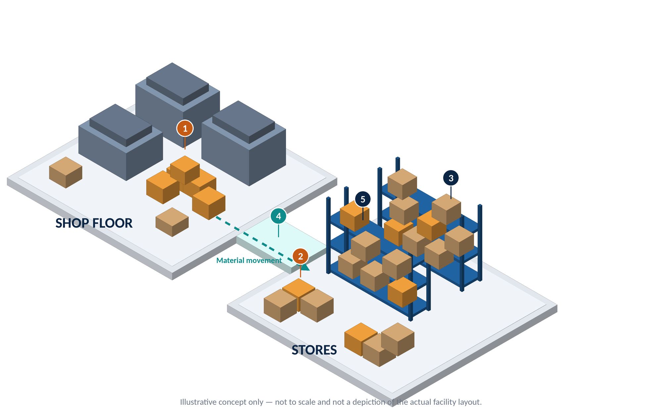
Figure 1 — Conceptual isometric view — shop floor, stores and material movement (illustrative)
Marker | Observation theme represented | Related observation IDs
1 | Materials kept directly on the floor (shop floor) | O-03
2 | Materials kept directly on the floor and in multiple places (stores) | O-01, O-03
3 | No consistent labeling system | O-06
4 | Material movement between shop floor and stores without point-of-use storage | O-10
5 | Storage without a structured, rack-based arrangement | O-02
Table 2 — Legend for Figure 1

3. Gemba Walk Methodology
The walk followed the sequence below. Figure 2 summarizes the flow; steps 4 and 5 depend on details that have not yet been documented and are marked accordingly.
1  Shop-Floor Visit  Understand materials used in actual operations | ➔ | 2  Stores Visit  Understand material storage and handling | ➔ | 3  Process Observation  Observe existing processes and daily problems | ➔ | 4  Feedback Collection  Capture issues and inputs | ➔ | 5  Problem Prioritization  Rank identified problems by severity
Areas visited: To be confirmed |  | Areas visited: To be confirmed |  | Participants: To be confirmed |  | Mechanism: To be confirmed |  | Rating criteria: To be confirmed
Figure 2 — Gemba Walk sequence (editable Word table; orange italics mark items pending confirmation)
Sequence rationale. Visiting the shop floor first establishes what materials are actually consumed and how; visiting the stores second shows how the same materials are held and issued. This order allows the stores’ practices to be judged against real demand rather than against assumed demand.
Pending confirmation — methodology details
The exact feedback mechanism used in step 4 and the severity-rating criteria used in step 5 have not been documented. Issues were prioritized by severity during the exercise, but the specific ratings and the criteria behind them have not yet been supplied. Both are listed in Section 7.

4. Gemba Walk Template: Five-Stage Assessment
The assessment is structured around the five stages of the Gemba Walk template used for this diagnostic study: Preparation, Observation, Improvement Opportunities, Follow-Up Actions and Reflection. The five-stage template applies to this diagnostic only and is not assumed to be the format for other Store Optimization workstreams.
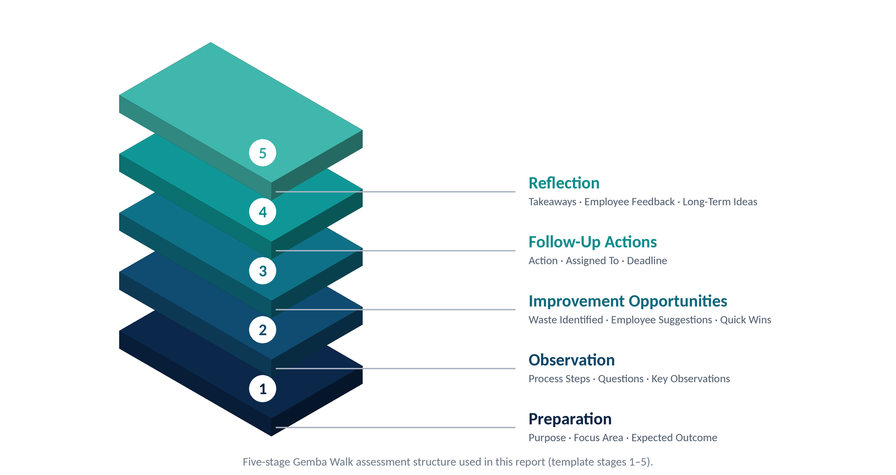
Figure 3 — Five-stage Gemba Walk assessment structure
Template field | Entry
Date | 07/05/2026
Department / Area | Factory 1 and 2
Manager’s name | Chandrahas Sir
Objective | Observe actual material use, storage, handling, identification and inventory practices as a fact-based starting point for the Store Optimization Project
Table 3 — Gemba Walk header information

4.1 Preparation
Template element | Entry
Purpose | To understand how materials are used on the shop floor, how they are stored and handled in the stores, and where operational problems arise, before structured improvements are developed.
Focus areas | Shop-floor material use; store layout; storage practices; material identification; material movement; inventory visibility; store processes.
Expected outcome | Identify operational gaps and establish a fact-based foundation for improvement.
Table 4 — Stage 1 — Preparation

4.2 Observation
Process steps. (
1) Shop-floor visit to understand materials used in operations;
(2) stores visit to understand storage and handling;
(3) observation of existing processes and daily problems;
(4) feedback capture;
(5) prioritization by severity.
Questions. The specific questions asked during the walk were not supplied (To be documented). The questions below are the guiding questions implied by the focus areas and are provided for validation sessions, not as a record of what was asked.
- Which materials are consumed on the shop floor, and where are they held today?
- Where, and in how many places, is each material stored?
- How does store staff know what stock is available, and how is stock counted?
- How are old, slow-moving or scrap materials identified and handled?

Key observations. Table 5 records the initial observations. “Potential operational implication” entries are potential only and are not confirmed impacts. Photograph cross-references will be added only once the relevant photographs are available and their references confirmed (Appendix A).
ID | Area / Theme | What was observed | Potential operational implication (not confirmed)
O-01 | Storage & space | The same materials were observed to be stored across different locations. | Potential: difficulty locating and counting materials; potential duplicate or fragmented stock.
O-02 | Storage & space | Items were being stored without a structured rack-based arrangement. | Potential: inefficient use of space and potential difficulty in access and retrieval.
O-03 | Storage & space | Some materials were stored directly on the shop floor. | Potential: occupied floor space, potential handling or safety concerns (to be assessed).
O-04 | Storage & space | Materials appeared to have remained in stock for many years. | Potential: space occupied by slow-moving or aged stock; relevance of stock to be established.
O-05 | Storage & space | A proper mechanism for identifying and disposing of scrap or obsolete materials was not evident during the initial observation. | Potential: continued accumulation of non-usable stock.
O-06 | Identification | Materials did not have a consistent labeling system. | Potential: time lost identifying items; potential picking or issuing errors.
O-07 | Inventory visibility | Store staff faced challenges with stock visibility. | Potential: uncertainty about what is available and where.
O-08 | Inventory visibility | Store staff faced stockout-related challenges. | Potential: potential disruption to operations when materials are unavailable.
O-09 | Inventory visibility | Material counting involved manual effort. | Potential: time-consuming counts and potential for count discrepancies.
O-10 | Movement & access | The absence of point-of-use storage increased material-handling requirements and labour movement. | Potential: additional travel and handling time between stores and point of use.
O-11 | Store practices | No structured 5S implementation was evident during the observed walk. | Potential: inconsistent housekeeping, organization and visual control.
O-12 | Store practices | No established FIFO practice was evident during the initial assessment. | Potential: older stock may not be consumed first.
O-13 | Store practices | No established Kanban replenishment mechanism was evident during the initial assessment. | Potential: replenishment not signal-driven; links to stockout challenges (O-08).
O-14 | Store practices | Structured binning and kitting practices were not evident during the initial assessment. | Potential: unstructured small-item storage and issue.
Table 5 — Initial observations from the Gemba Walk (Stage 2 — Observation)

4.3 Improvement Opportunities
The observations are grouped into nine opportunity areas. All entries are proposed opportunities, not confirmed implementations, and no benefit is claimed.

Waste identified (potential)
The observations point to the following Lean waste categories as potential areas of focus. These are hypotheses to be confirmed through validation and baseline data, not measured findings.
Potential waste category | Linked observations | Basis
Motion | O-01, O-06, O-09, O-10 | Searching, identifying and counting materials; travel to and from stores
Transportation | O-10 | Material handling between stores and point of use
Inventory | O-01, O-04, O-05 | Long-held stock and unstructured accumulation
Waiting | O-07, O-08 | Possible delays when stock is unavailable or hard to locate
Table 6 — Potential waste categories linked to observations

Opportunity areas
Opportunity area | Observed condition | Improvement opportunity | Potential quick win | Further information / validation required
Structured storage and rack utilization | O-01, O-02, O-03: same materials in different locations; no structured racks; materials on floor. | Establish a structured, rack-based storage arrangement with defined locations. | Mark and define temporary staging zones for materials currently kept on the floor. | Inventory of items and locations; available space; storage requirements by item.
Material location identification and labeling | O-06, O-07: no consistent labeling; stock-visibility challenges. | Introduce a consistent location and item identification scheme. | Pilot standard labels in one selected zone. | Item master and location list; label content standard.
Point-of-use storage and material movement | O-10: no point-of-use storage; added handling and labour movement. | Evaluate storing high-use materials closer to where they are consumed. | Trial a nearest-to-use location for a few frequently used items. | Consumption frequency by item; current travel pattern.
Old, slow-moving, obsolete and scrap stock review | O-04, O-05: long-held stock; no disposal mechanism evident. | Define a method to identify, review and dispose of non-usable stock. | Set up a red-tag / quarantine area for items suspected to be obsolete, pending review. | Stock ageing and last-movement data; approval route for disposal.
FIFO discipline | O-12: no established FIFO evident. | Define a first-in-first-out practice suited to the materials concerned. | Pilot date-tagging or lane arrangement for one item group. | Which materials are shelf-life or age sensitive; receipt data.
Binning and kitting | O-14: structured binning and kitting not evident. | Evaluate bins for small items and kits for repeated assemblies or jobs. | Trial bins for a selected small-item family. | Bill-of-material / job material needs; item dimensions and volumes.
Inventory visibility and manual counting | O-07, O-09: visibility challenges; manual counting. | Improve stock visibility and reduce manual counting effort. | Pilot a simple cycle-count sheet for a few critical items. | Current counting method, frequency and any accuracy records.
Replenishment control and Kanban | O-08, O-13: stockout challenges; no Kanban evident. | Evaluate signal-based replenishment for suitable items. | Identify a small candidate set of fast-moving items for a later pilot. | Consumption and lead-time data; supplier terms; ABC/XYZ result.
5S and visual management | O-11: no structured 5S evident. | Establish 5S routines and visual controls. | Run a Sort (first S) exercise in one selected zone. | Agreed zone and ownership; baseline condition photographs.
Table 7 — Improvement opportunity areas (proposed, not implemented)

Template element | Entry
Employee suggestions | To be documented. No employee suggestions were supplied for this draft, and none are inferred.
Quick wins | Proposed quick wins appear in Table 7 and are subject to validation and owner agreement.
Table 8 — Stage 3 — Employee suggestions and quick wins

4.4 Follow-Up Actions
The register below lists proposed follow-up actions derived from the observations. Issues were prioritized by severity during the exercise; however, the specific ratings and the rating criteria have not yet been supplied and are therefore not shown. No owners, deadlines or completed actions are assumed.
Action ID | Observation / Opportunity ref. | Proposed action
A-01 | O-01 to O-14 | Validate all initial observations with store staff and relevant managers.
A-02 | Method (step 4) | Document the feedback mechanism used and consolidate the feedback captured.
A-03 | Method (step 5) | Confirm severity-rating criteria and record the rating of each problem.
A-04 | O-01, O-04, O-07, O-09 | Collect baseline data: item and location list, stock counts, ageing of stock.
A-05 | O-01, O-02, O-03 | List materials stored on the floor and in multiple locations.
A-06 | O-04, O-05 | Review old stock and propose a scrap / obsolete identification and disposal process.
A-07 | O-06, O-07 | Propose a consistent labeling and location identification scheme.
A-08 | O-10 | Assess point-of-use storage options for high-use materials.
A-09 | O-12 | Define the FIFO approach and identify a pilot item group.
A-10 | O-14 | Identify candidates for binning and kitting.
A-11 | O-08, O-13 | Assess candidate items for Kanban replenishment after ABC/XYZ analysis.
A-12 | O-11 | Select a pilot zone and plan 5S activities.
A-13 | O-09 | Assess options to reduce manual counting effort.
A-14 | All | Assign owners and target dates; agree review cadence.
Table 9 — Follow-up action register (all actions proposed; none confirmed as completed)

4.5 Reflection
Template element | Entry
Takeaways | Observing the actual shop floor and stores first-hand surfaces practical issues — such as storage arrangement, identification and movement — that are difficult to see from records alone. Understanding existing processes before designing solutions reduces the risk of designing improvements that do not fit actual use.
Employee feedback | To be documented.
Long-term ideas | Ideas to be investigated through the subsequent Store Optimization workstreams (ABC and XYZ analysis, rack designing, binning, labeling, FIFO, kitting and Kanban); none is implemented or assumed to deliver a particular benefit.
Table 10 — Stage 5 — Reflection
Validation need. Because the observations come from a single walk, they must be validated with store staff and relevant managers before they are treated as established problems or used to size any solution.

5. Consolidated Diagnostic Findings
The matrix below consolidates the observations into findings and links each to the relevant Store Optimization workstream. The workstreams are future or separate project components; this report does not imply that any has been implemented.
Finding | Evidence available | Potential operational implication | Validation required | Related workstream
F-1 Fragmented, unstructured and floor storage (O-01 to O-03) | Direct observation; | Potential difficulty in locating, accessing and counting materials; potential space inefficiency | Item–location mapping; space assessment | FSN analysis; Rack designing
F-2 Long-held stock; no disposal mechanism evident (O-04, O-05) | Direct observation | Potential occupation of space by non-usable stock | Stock ageing data; usage history | FSN analysis (stock review input)
F-3 Inconsistent identification (O-06) | Direct observation | Potential identification time and picking errors | Labeling baseline; item master | Labeling
F-4 Stock visibility, stockouts and manual counting (O-07 to O-09) | Direct observation; staff challenges noted | Potential uncertainty of availability; potential disruption from stockouts | Stock records; counting method; stockout instances | Labeling; FSN analysis; Kanban
F-5 No point-of-use storage (O-10) | Direct observation | Potential added handling and labour movement | Consumption points; travel pattern | Rack designing; Binning; Kitting
F-6 No structured 5S evident (O-11) | Direct observation | Potential inconsistent organization and visual control | Agreed 5S baseline | Cross-cutting — supports all workstreams
F-7 No established FIFO evident (O-12) | Direct observation | Potential for older stock not being used first | Material ageing sensitivity; receipt data | FIFO
F-8 No established Kanban evident (O-13) | Direct observation | Potential for non-signal-driven replenishment | Consumption and lead-time data | Kanban
F-9 Binning and kitting not evident (O-14) | Direct observation | Potential unstructured small-item storage and issue | Candidate item list | Binning; Kitting
Table 11 — Consolidated diagnostic findings matrix

Link to Store Optimization workstreams
No. | Workstream | Linked findings
1 | ABC and XYZ analysis | F-1, F-2, F-4
2 | Rack designing | F-1, F-5
3 | Binning | F-5, F-9
4 | Labeling | F-3, F-4
5 | FIFO | F-7
6 | Kitting | F-5, F-9
7 | Kanban | F-4, F-8
Table 12 — Mapping of findings to workstreams

Appendix A: Photographic Evidence
All factory and store photographs belong in this appendix. The register below is ready for manual insertion; captions are placeholders only and should be adjusted to match the actual photographs. Placeholders do not imply that photographs have been provided or depict verified conditions. Cross-references in Table 5 will be added once photographs are confirmed.
Photo ID | Photograph
Photo A1 | 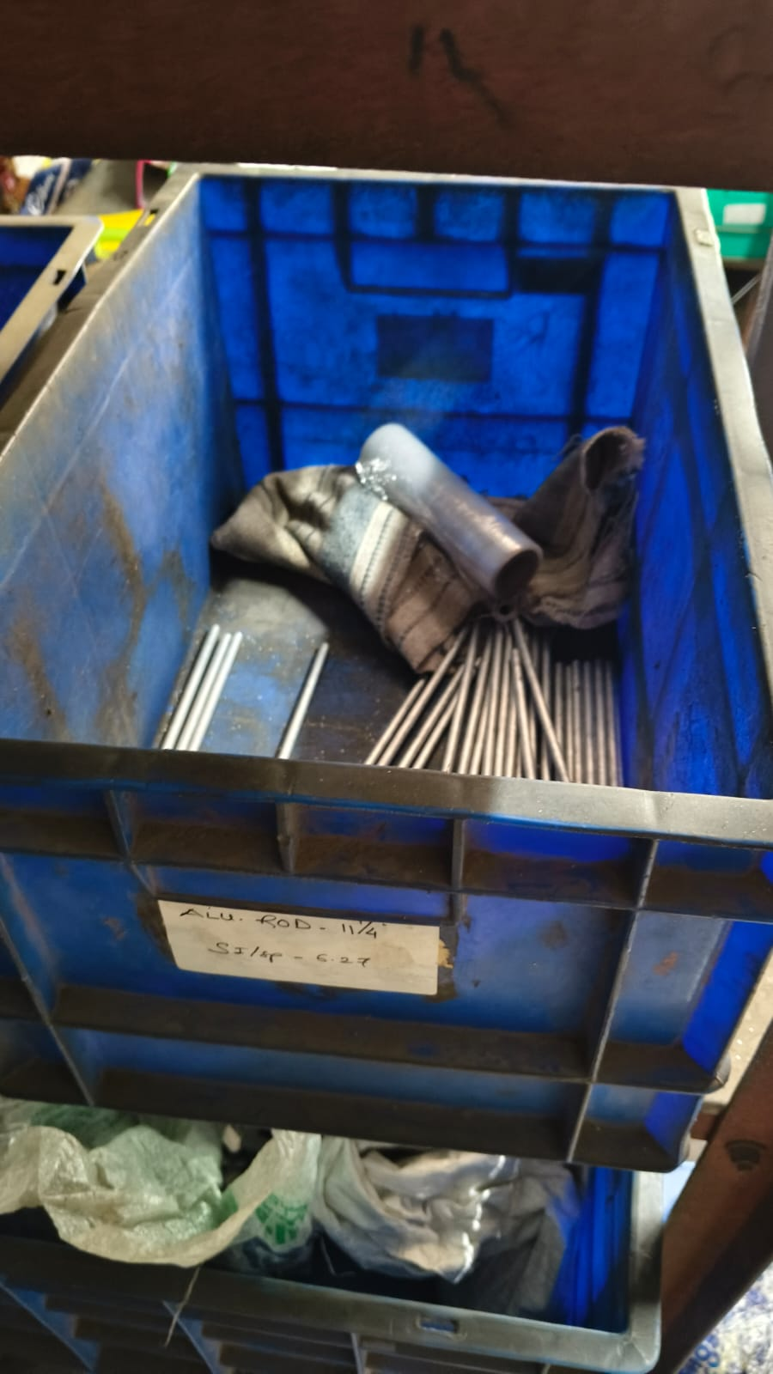
Photo A2 | 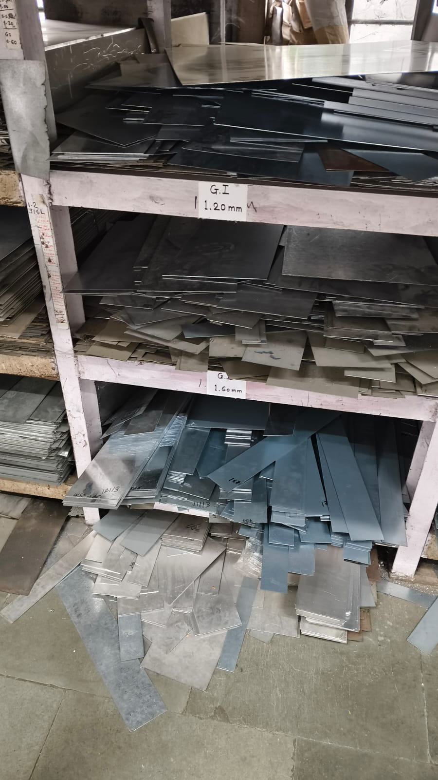
Photo A3 | 